Medical Education Week Seminar Series
Sponsored by The Society of Teaching Scholars

“How Will ‘generation Y’ Learn Medicine”

By:

Anthony T. Yachnis, M.D.,
Department of Pathology, Immunology, and Laboratory Medicine
UF College of Medicine Basic Science Teacher of the Year 2010-11
Learning Objectives:
- Review generational differences influencing how and what we teach in medical school
- Define characteristics of “Generation Y” (the millennial generation) that affect learning
- Understand the importance of mentorship and feedback

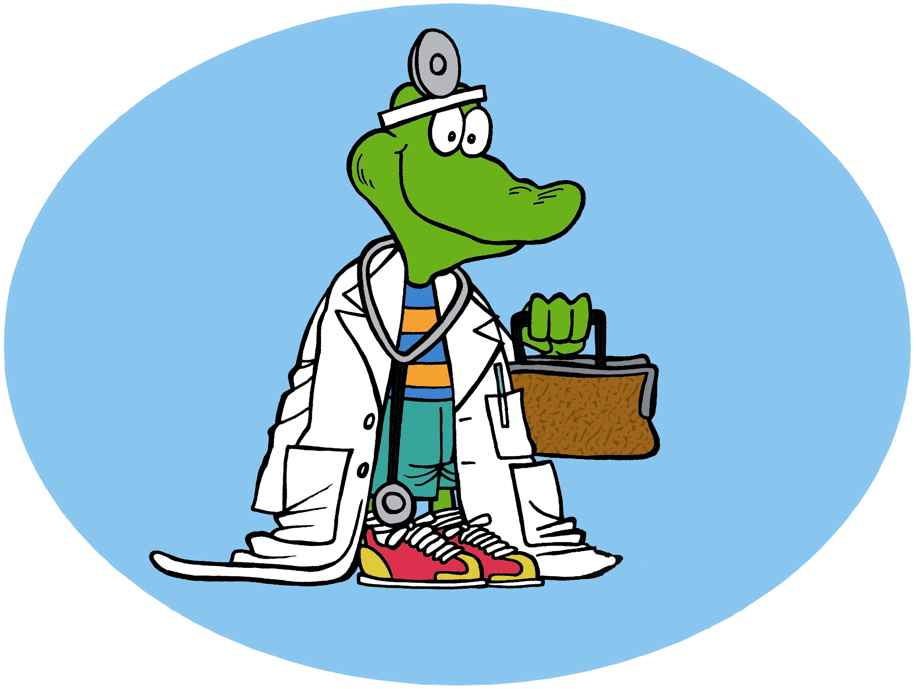

Monday, February 20, 2012
Noon – 1pm
Communicore Building, Room C1-7
Video-Conferenced to Jacksonville-Alumni Auditorium
Disclosure
Speaker has disclosed that he has no relevant financial relationships. No one else in a position to control content has any financial relationship(s) to disclose.

Accreditation The University of Florida College of Medicine is accredited by the Accreditation Council for Continuing Medical Education to provide continuing medical education for physicians.

Credit The University of Florida College of Medicine designates this education activity for a maximum of 1 AMA PRA Category 1 Credit™. Physicians should only claim credit commensurate with the extent of their participation in the activity.

~~ Lunch provided with RSVP to ssorci@ufl.edu (Gainesville only) ~~
For more information, please call 273-7985

CME Section # 3018

